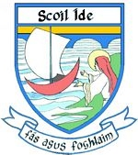

6th June, 2025.
Dear Parent(s)/Guardian(s),

The following are the arrangements for closings/re-openings/holidays for School Year 2025-2026.

SEPTEMBER: Re-opening on 1st

OCTOBER: Mid-term: Closing on 24th

NOVEMBER: Re-opening on 3rd

DECEMBER: Closed on 8th
Christmas Holidays: Closing on 19th

JANUARY: Re-opening on 7th

FEBRUARY: Closed on 2nd
Midterm: Closed on 19th & 20th

MARCH: Closed on 17th
Easter Holidays: Closing on 27th

APRIL: Re-opening on 13th

MAY: Closed on 1st & 4th

JUNE: Closed on 1st
Summer Holidays – Closing on 30th

Yours sincerely,

Mr. P. Coyle,
Principal.

